WEEK 2-PL/SQL PROGRAMMING

SUPERSET ID:6383615
EXERCISE 1-CONTROL STRUCTURES
SCENARIO 1
CREATE TABLE bank_customers (
customer_id NUMBER PRIMARY KEY,
name VARCHAR2(50),
age NUMBER,
balance NUMBER,
interest_rate NUMBER(5,2),
isVIP VARCHAR2(5)
);
INSERT INTO bank_customers VALUES (1, 'Alice', 65, 12000, 7.5, 'FALSE');
INSERT INTO bank_customers VALUES (2, 'Bob', 45, 8000, 6.0, 'FALSE');
INSERT INTO bank_customers VALUES (3, 'Charlie', 70, 15000, 8.0, 'FALSE');
INSERT INTO bank_customers VALUES (4, 'David', 30, 5000, 5.5, 'FALSE');
COMMIT;
/
select * from bank_customers;
INITIAL TABLE
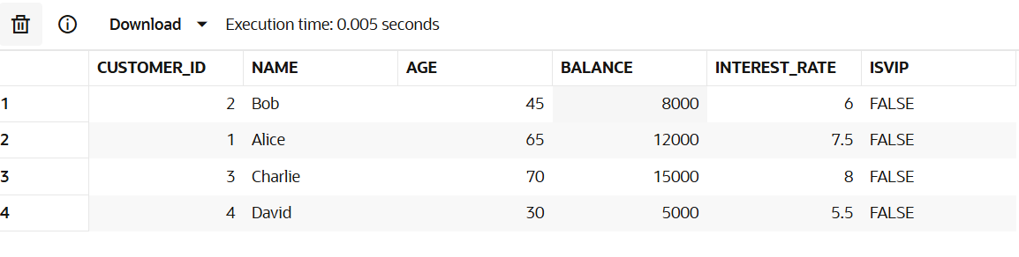
BEGIN
FOR customer_rec IN (
SELECT customer_id
FROM bank_customers
WHERE age > 60
) LOOP
UPDATE bank_customers
SET interest_rate = interest_rate - 1
WHERE customer_id = customer_rec.customer_id;
END LOOP;
COMMIT;
END;
/
select * from bank_customers;
OUTPUT FOR SCENARIO 1
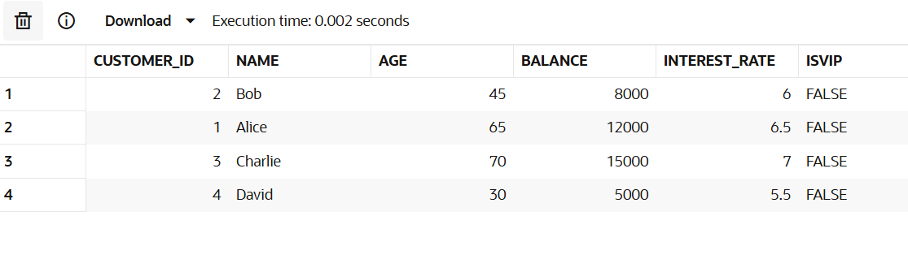
SCENARIO 2
BEGIN
FOR customer_rec IN (
SELECT customer_id
FROM bank_customers
WHERE balance > 10000
) LOOP
UPDATE bank_customers
SET isVIP = 'TRUE'
WHERE customer_id = customer_rec.customer_id;
END LOOP;
COMMIT;
END;
/
SELECT
customer_id, name, age, balance, interest_rate, isVIP
FROM
bank_customers
ORDER BY
customer_id;
OUTPUT FOR SCENARIO 2
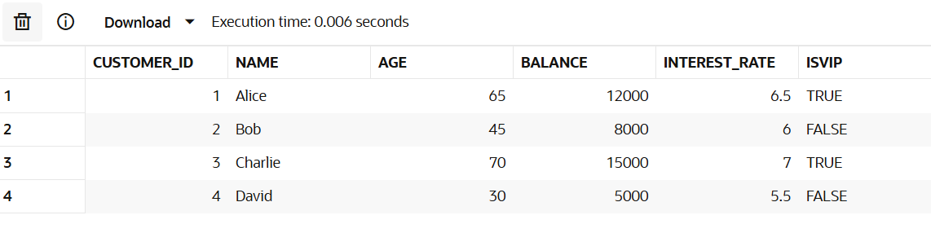
SCENARIO 3
ALTER TABLE bank_customers ADD (due_date DATE);
UPDATE bank_customers SET due_date = SYSDATE + 10 WHERE customer_id = 1;
UPDATE bank_customers SET due_date = SYSDATE + 35 WHERE customer_id = 2;
UPDATE bank_customers SET due_date = SYSDATE + 5 WHERE customer_id = 3;
UPDATE bank_customers SET due_date = SYSDATE - 2 WHERE customer_id = 4;
COMMIT;
BEGIN
FOR cust_rec IN (
SELECT name, due_date
FROM bank_customers
WHERE due_date BETWEEN SYSDATE AND SYSDATE + 30
) LOOP
DBMS_OUTPUT.PUT_LINE(
'Reminder: Loan for ' || cust_rec.name ||
' is due on ' || TO_CHAR(cust_rec.due_date, 'DD-MON-YYYY')
);
END LOOP;
END;
/
OUTPUT FOR REMINDER
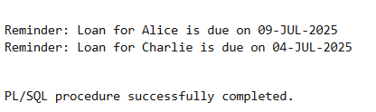
SELECT
customer_id,
name,
age,
balance,
interest_rate,
isVIP,
TO_CHAR(due_date, 'DD-MON-YYYY') AS due_date
FROM
bank_customers
ORDER BY
customer_id;
FINAL TABLE OUTPUT FOR SCENARIO 3
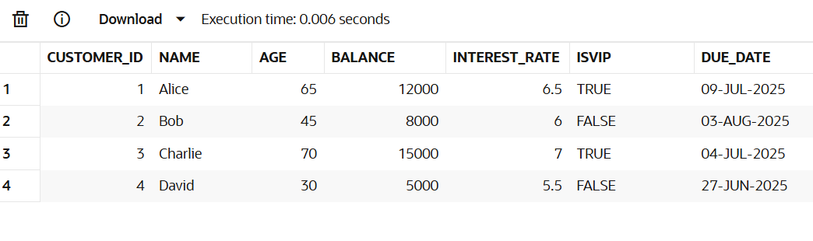

EXERCISE 3-STORED PROCEDURES
SCENARIO 1
CREATE TABLE savings_accounts (
account_id NUMBER PRIMARY KEY,
customer_name VARCHAR2(50),
balance NUMBER(10, 2)
);
/
INSERT INTO savings_accounts VALUES (101, 'Arun', 10000);
INSERT INTO savings_accounts VALUES (102, 'Aravind', 7500);
INSERT INTO savings_accounts VALUES (103, 'Ram', 15000);
COMMIT;
/
select * from savings_accounts;
INITIAL TABLE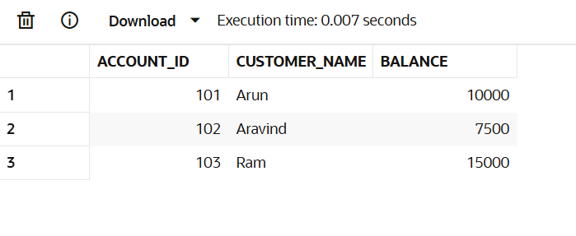
CREATE OR REPLACE PROCEDURE ProcessMonthlyInterest IS
BEGIN
UPDATE savings_accounts
SET balance = balance + (balance * 0.01);
COMMIT;
END;
/

EXEC ProcessMonthlyInterest;
OUTPUT FOR SCENARIO 1
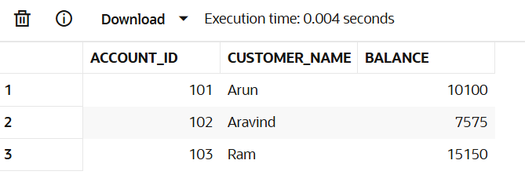SCENARIO 2
CREATE TABLE employees (
emp_id NUMBER PRIMARY KEY,
name VARCHAR2(50),
department VARCHAR2(30),
salary NUMBER(10, 2)
);
/
INSERT INTO employees VALUES (1, 'Arun', 'HR', 40000);
INSERT INTO employees VALUES (2, 'Aravind', 'IT', 50000);
INSERT INTO employees VALUES (3, 'Ram', 'IT', 60000);
COMMIT;
/
SELECT * FROM employees ORDER BY emp_id;
INITIAL TABLE
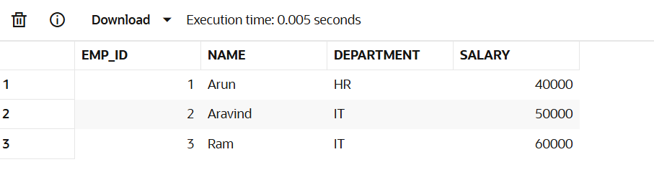
CREATE OR REPLACE PROCEDURE UpdateEmployeeBonus (
dept_name IN VARCHAR2,
bonus_percent IN NUMBER
) IS
BEGIN
UPDATE employees
SET salary = salary + (salary * bonus_percent / 100)
WHERE department = dept_name;
COMMIT;
END;
/
EXEC UpdateEmployeeBonus('IT', 10);
SELECT * FROM employees ORDER BY emp_id;
OUTPUT FOR SCENARIO 2
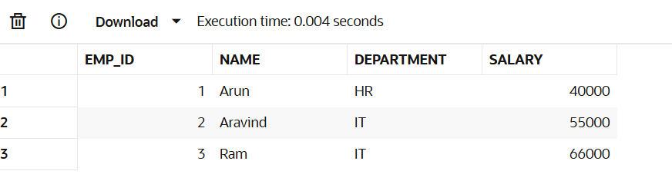
SCENARIO 3
CREATE TABLE accounts (
account_number NUMBER PRIMARY KEY,
customer_name VARCHAR2(50),
balance NUMBER(10, 2)
);
/
INSERT INTO accounts VALUES (201, 'Arun', 8000);
INSERT INTO accounts VALUES (202, 'Aravind', 5000);
INSERT INTO accounts VALUES (203, 'Ram', 9000);
COMMIT;
/
SELECT * FROM accounts;

INITIAL TABLE
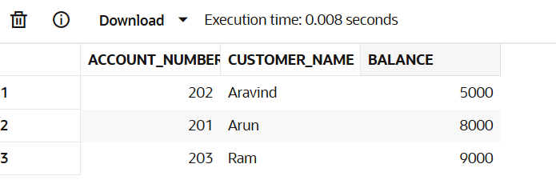
CREATE OR REPLACE PROCEDURE TransferFunds (
from_account IN NUMBER,
to_account IN NUMBER,
amount IN NUMBER
) IS
insufficient_balance EXCEPTION;
curr_balance NUMBER;
BEGIN
SELECT balance INTO curr_balance FROM accounts WHERE account_number = from_account;

IF curr_balance < amount THEN
RAISE insufficient_balance;
END IF;

UPDATE accounts
SET balance = balance - amount
WHERE account_number = from_account;

UPDATE accounts
SET balance = balance + amount
WHERE account_number = to_account;

COMMIT;
EXCEPTION
WHEN insufficient_balance THEN
DBMS_OUTPUT.PUT_LINE('Error: Insufficient balance in source account.');
WHEN NO_DATA_FOUND THEN
DBMS_OUTPUT.PUT_LINE('Error: Account not found.');
WHEN OTHERS THEN
DBMS_OUTPUT.PUT_LINE('Unexpected error: ' || SQLERRM);
END;
/
EXEC TransferFunds(201, 202, 3000);
SELECT * FROM accounts ORDER BY account_number;

OUTPUT FOR SCENARIO 3(AMOUNT TRANSFERRED FROM ARUN TO ARAVIND)
